## **Daily Scrum Chats**



Resim - 25.04.2022 Daily Scrum

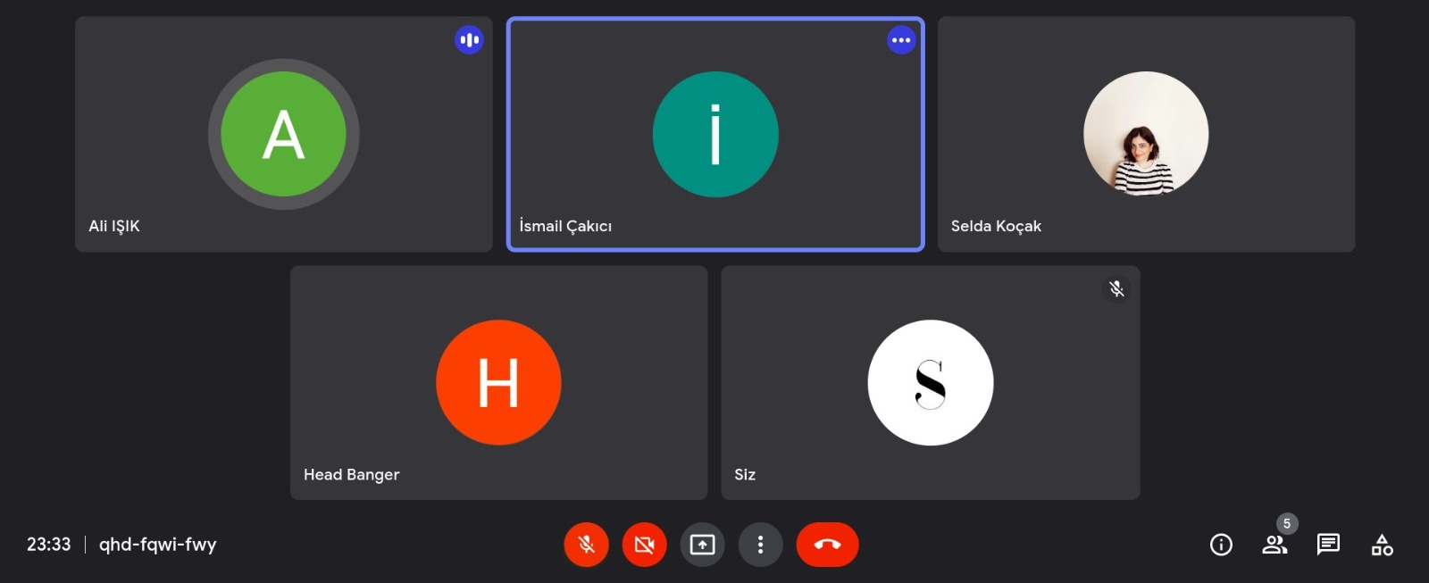

Resim - 26.04.2022 Daily Scrum

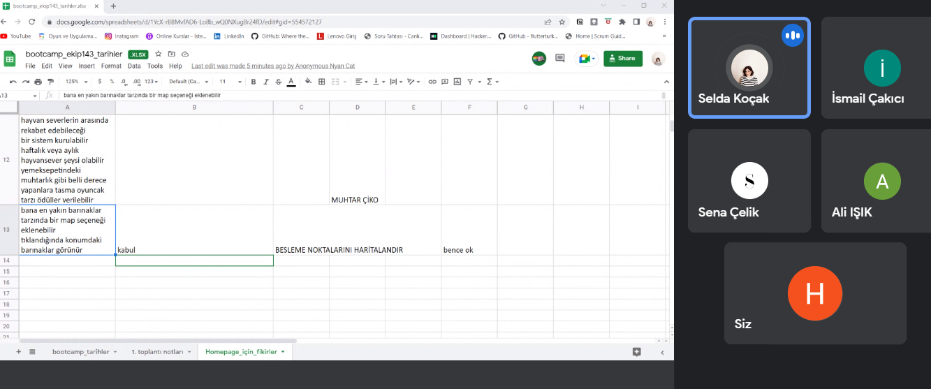

Resim - 27.04..2022 Daily Scrum

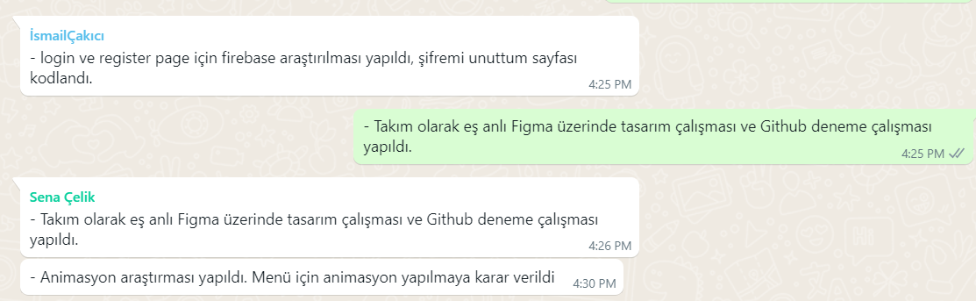

Resim - 28.04.2022 Daily Scrum

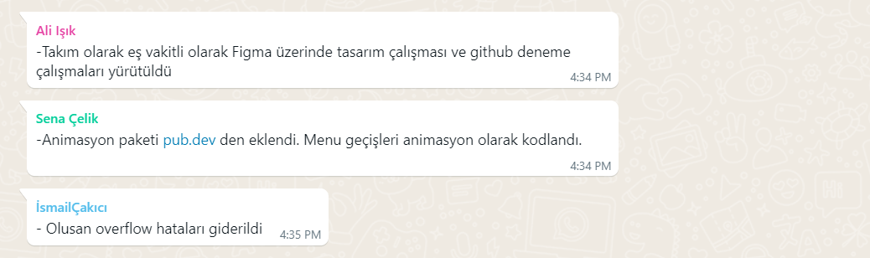

Resim - 29.04.2022 Daily Scrum

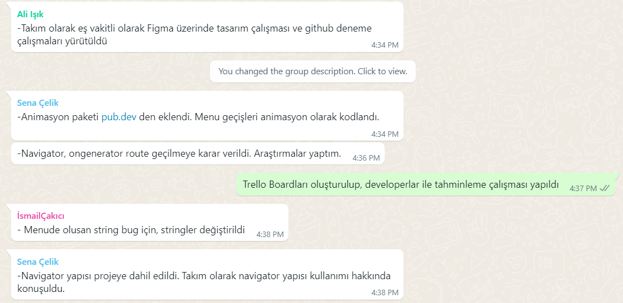

Resim - 30.04.2022 Daily Scrum

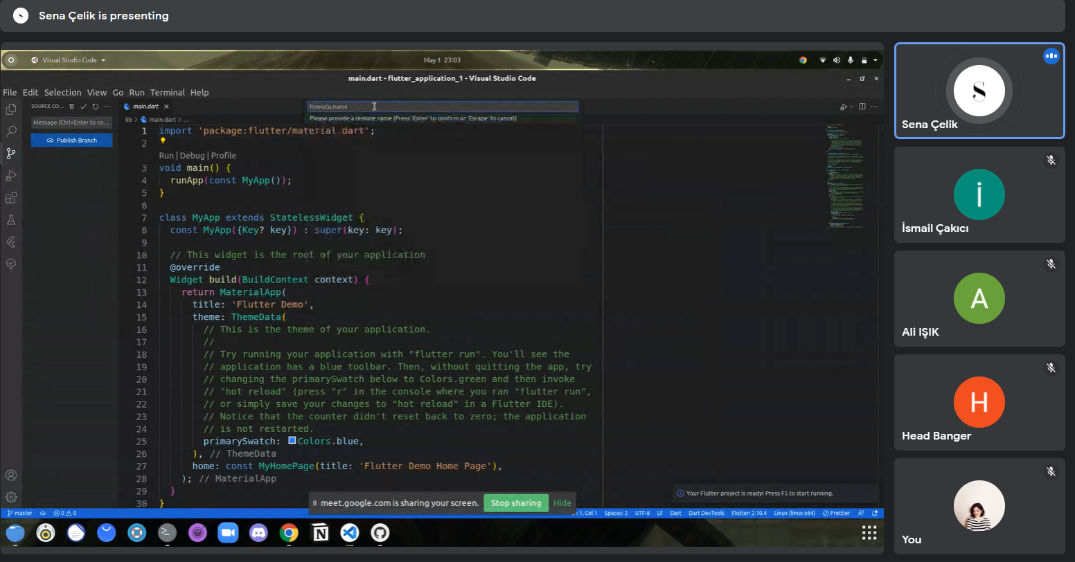

Resi - 01.05.2022 Daily Scrum

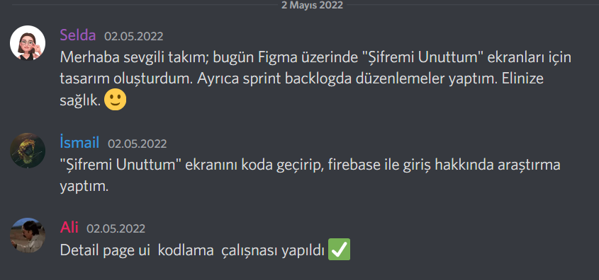

Resim - 02.05..2022 Daily Scrum

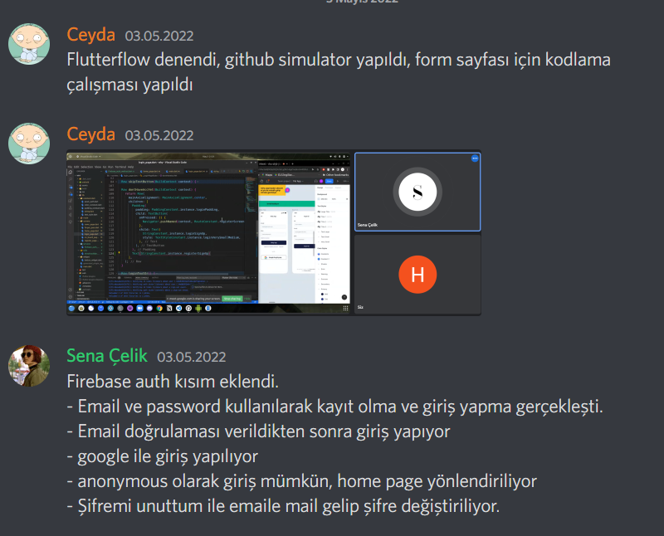

Resim - 03.05.2022 Daily Scrum

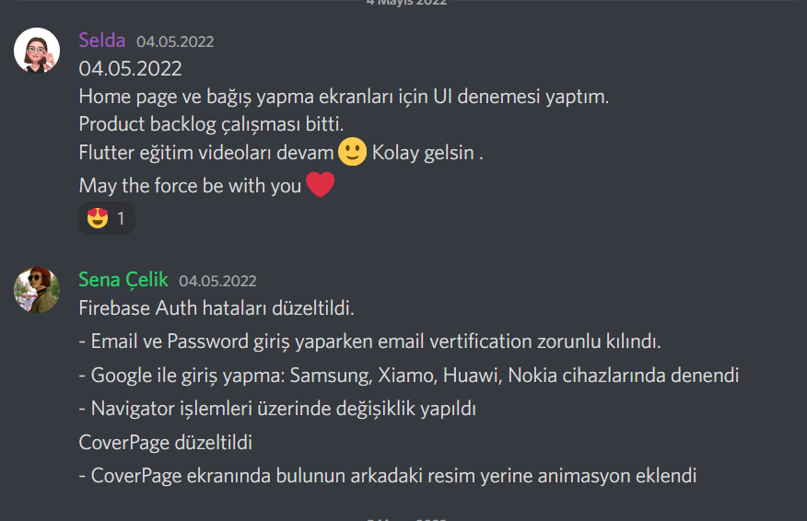

Resim - 04.05.2022 Daily Scrum

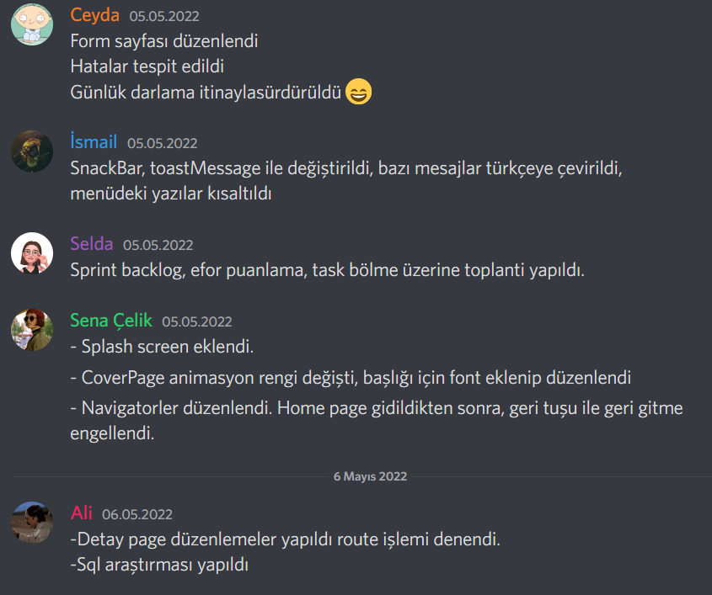

Resim - 05.05.2022 Daily Scrum

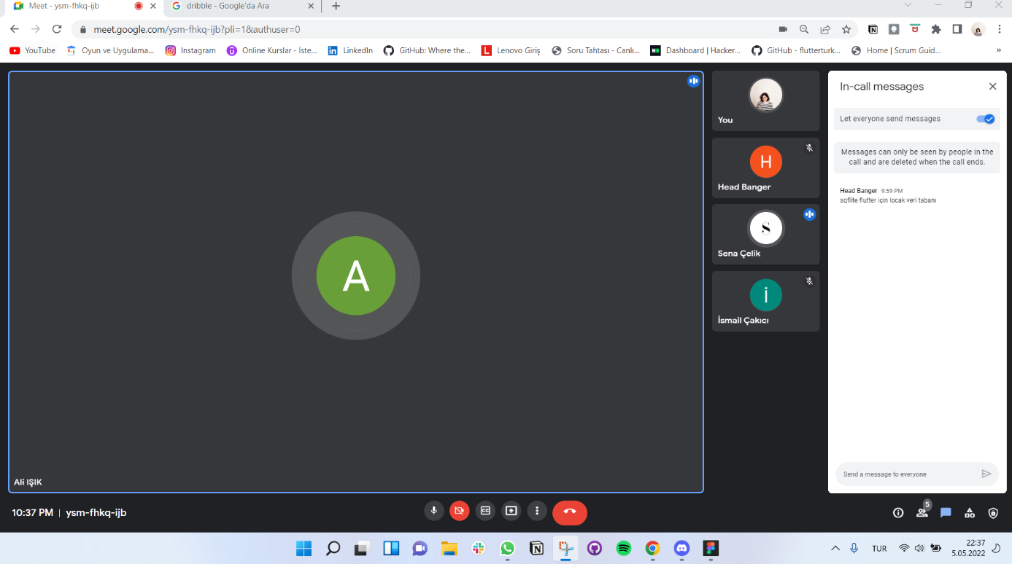

Resim - 06.05.2022 Daily Scrum

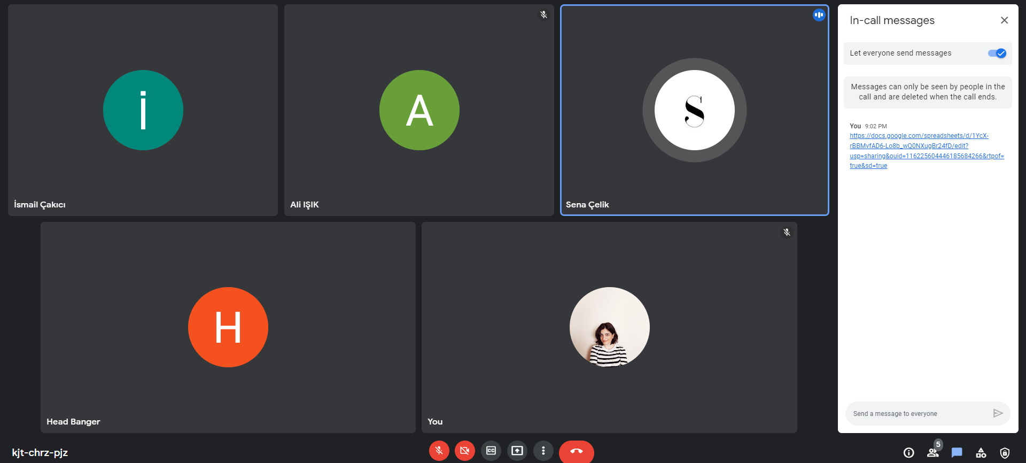

Resim - 07.05.2022 Daily Scrum

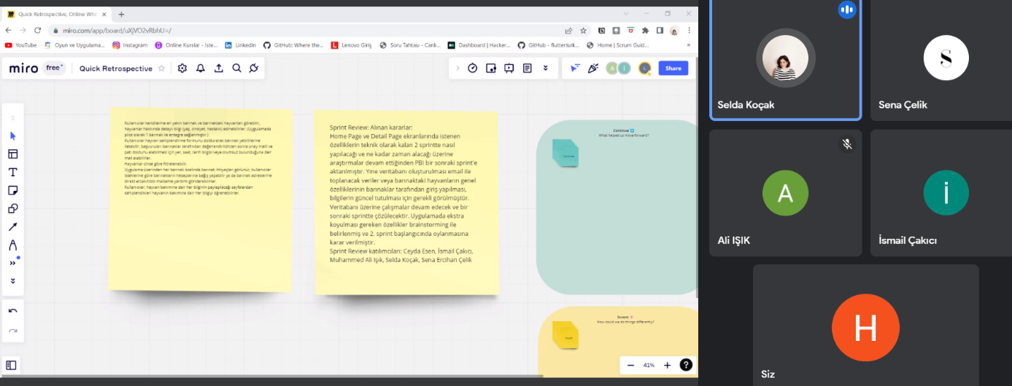

Resim - 08.05.2022 Daily Scrum